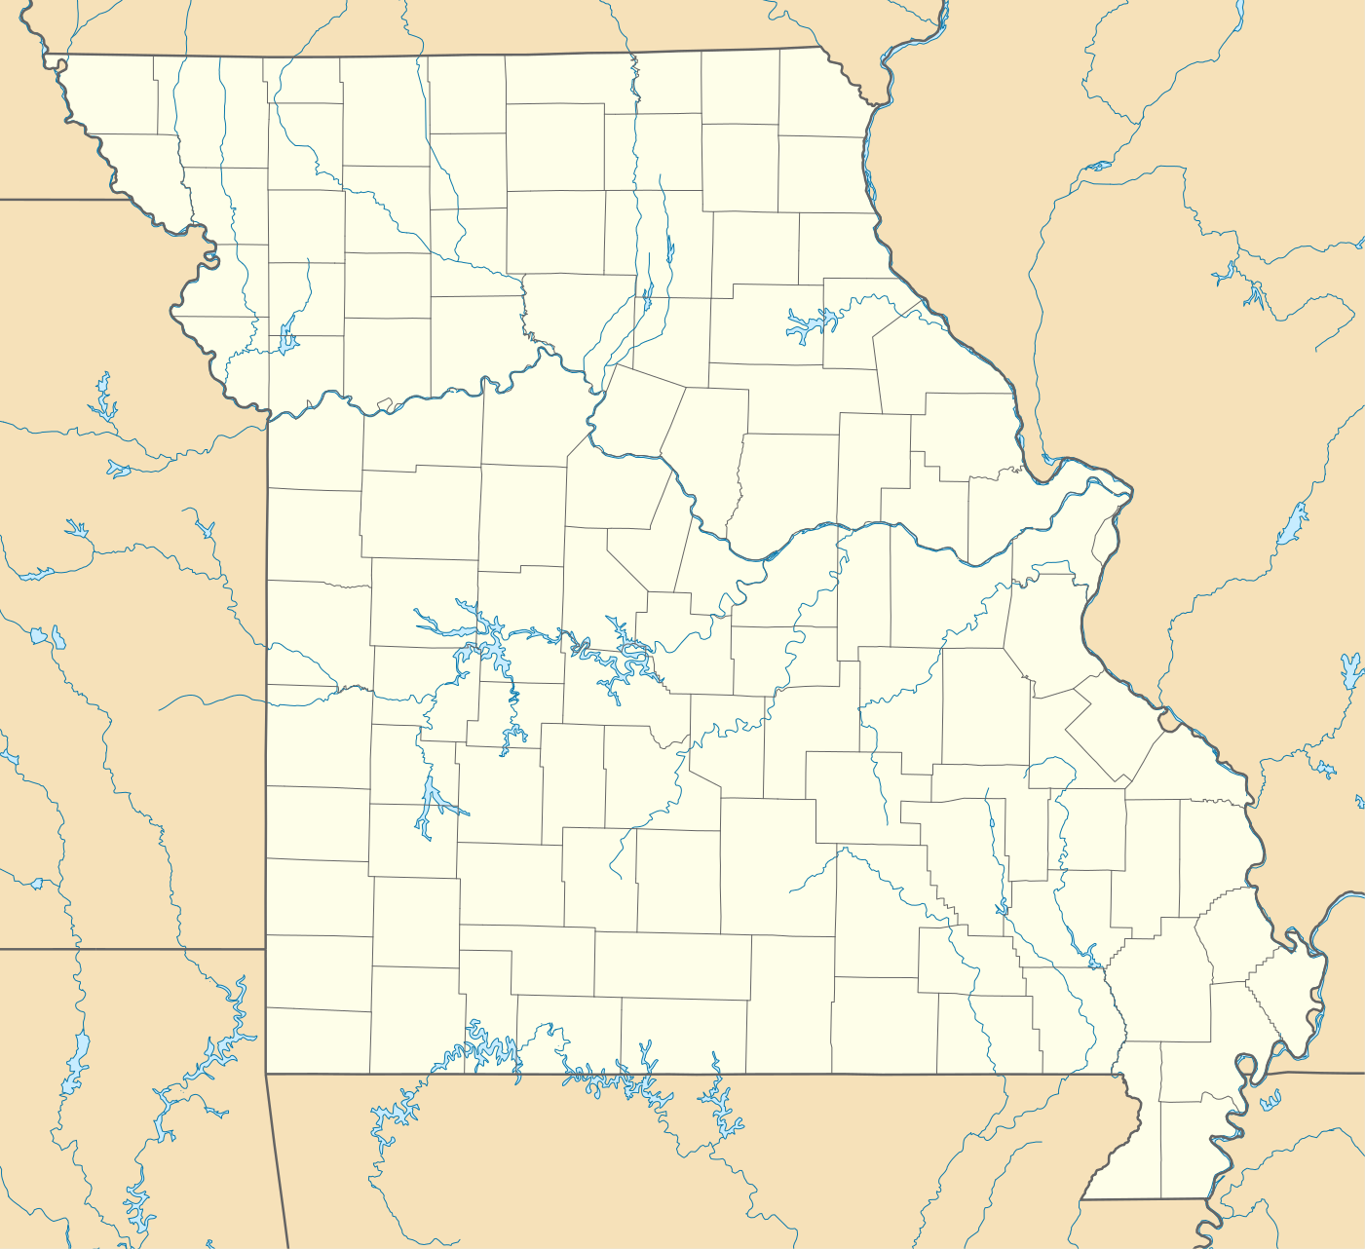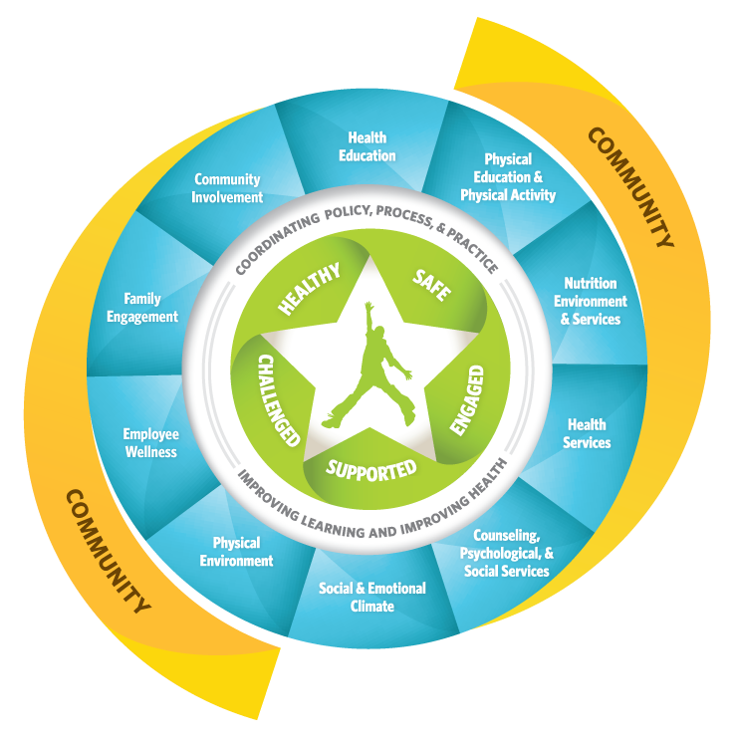

Please reach out to us!

Missouri Coordinated School Health Coalition

PO Box 104893

Jefferson City, MO 65110

Email: info@healthykidsmo.org

Also visit

<http://www.cdc.gov/healthyschools/wscc/index.htm>

Who we are:

* Collaborative of organizations and individuals whose primary responsibility is to assist schools in their student health and wellness initiatives

Our mission:

* Advocating for a Coordinated School Health Program in every Missouri school to ensure students learn to be healthy and are healthy to learn.

Our Vision:

* Healthy, active students becoming healthy, active and productive adults.

Whole Child

Whole Community

Missouri Coordinated School Health Coalition

Whole School

## About Us

Whole School, Whole Community, Whole Child. (2015, October 16). Retrieved March 15, 2016, from http://www.cdc.gov/healthyyouth/wscc/

“The Whole School, Whole Community, Whole Child (WSCC) model is an expansion and update of the Coordinated School Health (CSH) approach. The WSCC incorporates the components of CSH and the tenets of the ASCD’s whole child approach to strengthen a unified and collaborative approach to learning and health. The WSCC model focuses its attention on the child, emphasizes a school-wide approach, and acknowledges learning, health, and the school as being a part and reflection of the local community.”

|  |  |  |
| --- | --- | --- |
| * Health and school health | * Responsibility |  |
| * Community Health | * Excellence | * Flexibility |

We want our youth to learn to be healthy and healthy to learn.

We aim to do this through:

### The Whole School, Whole Community, Whole Child Model

# A Collaborative Approach…